Course: IT Investigation Incident
Instructor: Professor Dr. Abdul Razaque, PhD & Postdoc
Machine Learning Semester Project
Students: Altynbekov Ali, Kamalov Timur
Group: CTC-241M
Project Title: Investigation of Social Engineering Attacks (Call, Email, SMS) Using Machine Learning
1. Introduction & Problem Statement
Social engineering attacks exploit human psychology rather than purely technical vulnerabilities. Typical examples include phishing emails, fraudulent SMS messages, and voice/robocall scams pretending to be banks, delivery services, or government agencies. These attacks are often the first step in larger incidents such as credential theft, account takeover, and financial fraud.
The goal of this project is to investigate social engineering across three common communication channels—SMS, email, and phone calls—using machine learning. The project compares how well simple models can distinguish malicious messages (spam, phishing, scams) from legitimate communication, and identifies typical linguistic and behavioral patterns that indicate social engineering attempts.
From an incident investigation perspective, such models can support Security Operations Center (SOC) analysts by prioritizing suspicious messages, providing indicators of compromise (IoCs), and revealing which channels carry the highest risk. The project focuses on supervised classification, basic text feature extraction, and comparative analysis of results across the three channels.
2. Dataset Description
This project uses three datasets, one per channel: SMS, email, and phone calls.
2.1 SMS: spam.csv (SMS Spam Collection)
The SMS dataset is based on the well-known “SMS Spam Collection” dataset, distributed via Kaggle and originally compiled by Almeida et al. for spam filtering research.
- Source: Kaggle / SMS Spam Collection (original corpus by Almeida et al.).
https://www.kaggle.com/code/dejavu23/sms-spam-or-ham-beginner/notebook
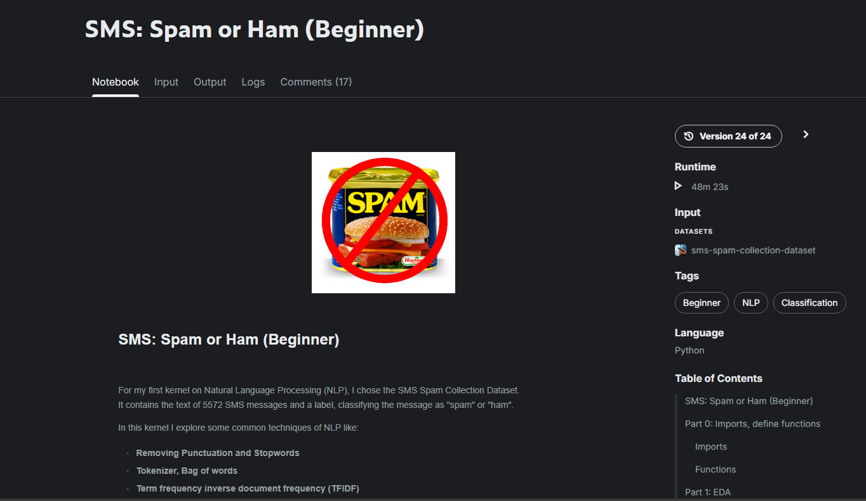
- Size: 5,572 SMS messages.
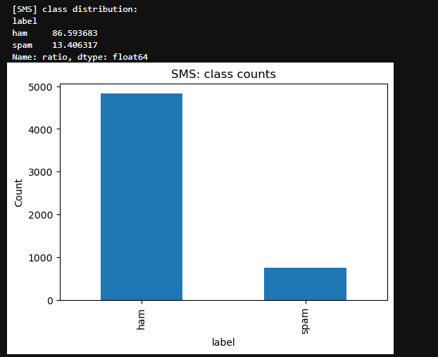
Figure 1. Class distribution for SMS
- Classes:
  - ham (legitimate) – 4,825 messages (≈ 86.6%)
  - spam (social-engineering / advertising / fraud) – 747 messages (≈ 13.4%)
- Key fields:
  - label – message class (ham or spam)
  - text – raw SMS message content
Basic length statistics (characters per message):
- Mean ≈ 80.3
- Median ≈ 67
- Minimum 2, maximum 910
Most messages are short, which is typical for SMS, but spam messages often contain slightly longer text including URLs and instructions.
2.2 Email: CEAS_08.csv (Phishing Email Dataset)
The email dataset comes from a phishing email corpus labeled for the CEAS 2008 conference spam/ham challenge and made available via Kaggle/figshare. ResearchGate
- Source: CEAS 2008 phishing email dataset (Kaggle / research corpus).
https://www.kaggle.com/datasets/naserabdullahalam/phishing-email-dataset/data
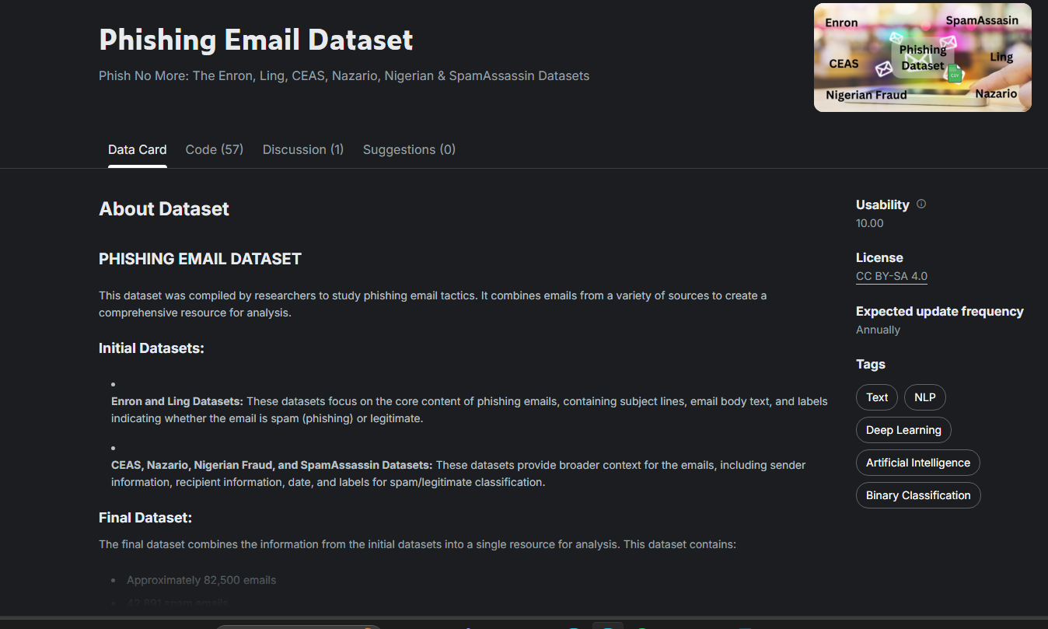
- Size: 39,154 messages.
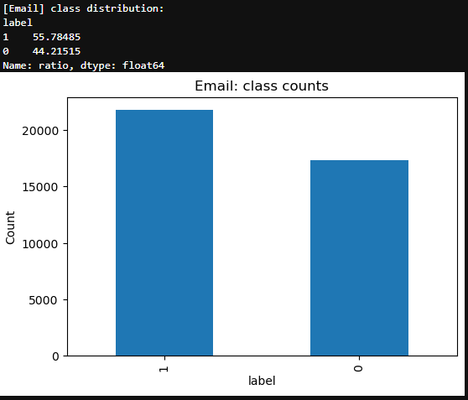
Figure 2. Class distribution for email
- Classes:
  - 1 – phishing / spam – 21,842 messages (≈ 55.8%)
  - 0 – legitimate – 17,312 messages (≈ 44.2%)
- Key fields:
  - subject – email subject line
  - body – email body content
  - label – binary label (1 = phishing, 0 = legitimate)
  - urls or similar fields containing extracted links
For modeling, a combined text field was created by concatenating subject and body.
Text length statistics (combined subject + body, in characters):
- Mean ≈ 2,038
- Median ≈ 1,423
- Minimum 8, maximum 50,000+
Emails are much longer than SMS and often contain HTML, long disclaimers, and embedded links.
2.3 Phone Calls: call_log.csv (Synthetic Voice / Robocall Data)
No suitable public dataset for phone scams with transcripts was available, so a small synthetic dataset was created to simulate call-based social engineering.
- Source: Manually constructed CSV.
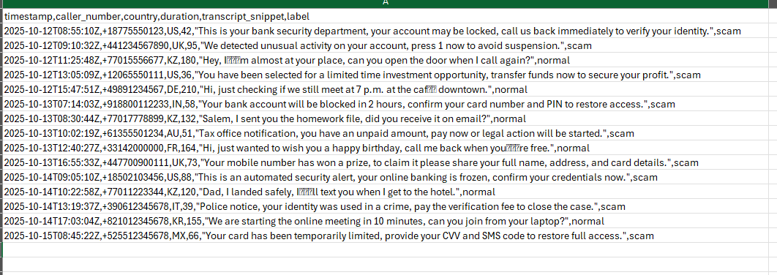
- Size: 15 calls.
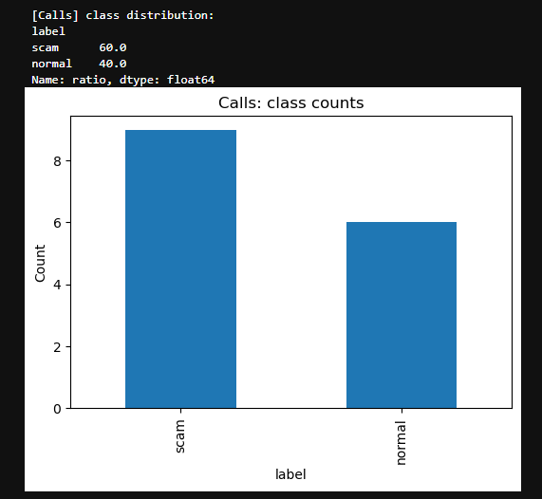
Figure 3. Class distribution for call
- Classes:
  - scam – 9 calls (60%)
  - normal – 6 calls (40%)
- Key fields:
  - timestamp – time of call
  - caller_number – calling phone number
  - country – country code (e.g., US, GB, IN)
  - duration – call duration in seconds
  - transcript_snippet – short text summary or key sentence from the call
  - label – scam or normal
Text length statistics for transcript_snippet:
- Mean ≈ 115 characters
- Median ≈ 108
- Minimum 53, maximum 205
Scam calls typically contain phrases like “your bank account will be locked” or “press 1 to speak to an agent,” while normal calls contain informal personal conversations.
2.4 Overall Class Distribution Summary
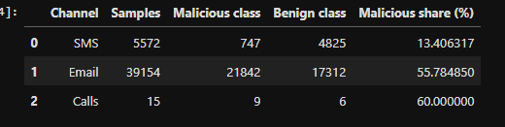
Figure 3. Class distribution for call
Table 1. Class distribution for call
Channel | Samples | Malicious class | Benign class | Malicious share
SMS | 5,572 | 747 spam | 4,825 ham | ≈ 13.4%
Email | 39,154 | 21,842 phishing | 17,312 legit | ≈ 55.8%
Calls | 15 | 9 scam | 6 normal | 60.0%

The email and call datasets are strongly biased towards malicious traffic, which is useful for studying detection but does not necessarily represent a real-world baseline.
Kaggle datasets are typically shared under terms allowing research and educational use, provided that proper attribution to the original authors and Kaggle source is retained. Kaggle
3. Methodology
3.1 Preprocessing
Each channel is modeled separately to respect differences in format and vocabulary:
- Text construction
  - SMS: use text directly from spam.csv.
  - Emails: concatenate subject and body into a single text field.
  - Calls: rename transcript_snippet to text.
- Label encoding
  - SMS: ham → 0, spam → 1.
  - Email: label already numeric (0 = legitimate, 1 = phishing).
  - Calls: normal → 0, scam → 1.
- Cleaning and features
  - Lowercasing of all text.
  - Punctuation and stopwords are handled implicitly by the TF–IDF vectorizer.
  - TF–IDF features with:
    - unigrams and bigrams (ngram_range=(1, 2)),
    - English stopword removal,
    - maximum vocabulary size of 10,000 tokens.
The data is split into training and test sets using train_test_split with 80/20 split and stratification by label where possible. For the very small call dataset, a slightly larger test fraction and careful stratification are used to avoid losing a class.
3.2 Machine Learning Models
Two models are trained for each channel:
- Logistic Regression (baseline)
  - Linear model that estimates the probability of a message being malicious (label = 1).
  - Works well with TF–IDF vectors and high-dimensional sparse features, acting as a strong baseline for text classification problems such as spam and phishing detection. UCI Machine Learning Repository
- Random Forest (improved model)
  - Ensemble of decision trees trained with bagging.
  - Captures non-linear relationships between n-gram features and labels.
  - More robust to outliers but can be less interpretable.
Both models are implemented using scikit-learn, wrapped in a Pipeline that combines TF–IDF feature extraction with the classifier. Metrics used for evaluation:
- Accuracy – overall fraction of correctly classified messages.
- Precision (malicious class) – how many predicted malicious messages are truly malicious.
- Recall (malicious class) – how many actual malicious messages are caught by the model.
- F1-score – harmonic mean of precision and recall.
Because incident investigation focuses on not missing attacks, recall for the malicious class is especially important.
4. Experiments & Results
4.1 Class Balance and Length Distributions
For each dataset, the class distribution and text length were analyzed.
- SMS: Only ≈13% of messages are spam, so the classifier must cope with class imbalance. Spams are often slightly longer and frequently contain URLs, phone numbers, and phrases like “free entry,” “call now,” or “claim your prize.”
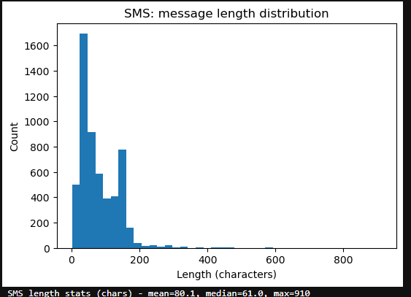
Figure 5. Length distribution of SMS messages.
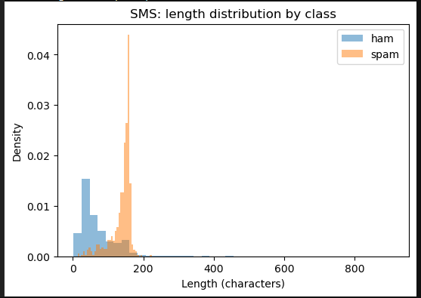
Figure 6. Length distribution of SMS messages by ham and spam
- Email: Phishing messages slightly dominate (≈56%). Many phishing emails contain HTML, long marketing text, and multiple URLs. Legitimate emails include corporate announcements and newsletters.
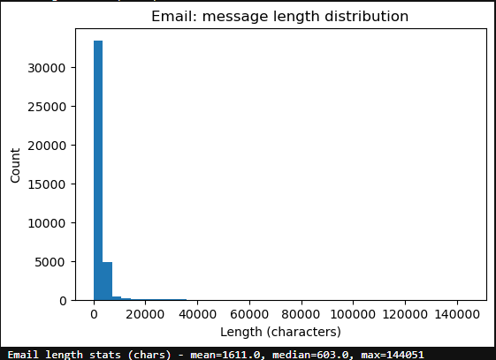
Figure 7. Length distribution of email messages
- Calls: The dataset is intentionally small but heavily malicious (60% scam). Scam transcripts are highly formulaic, often mentioning banks, taxes, or account locking and urging the recipient to “act immediately” or “press 1.”
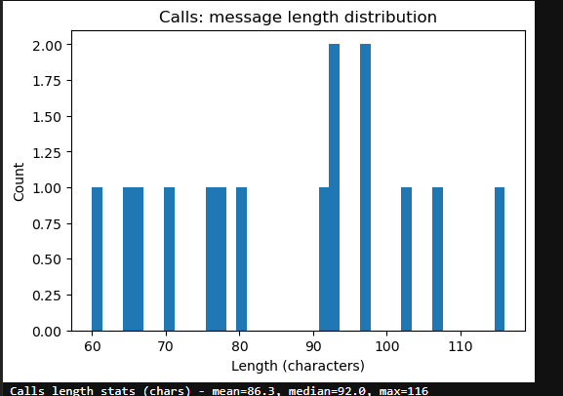
Figure 8. Length distribution of call messages.
In the notebook, histograms are plotted for message length and bar charts for class counts per channel. These show:
- SMS distribution sharply peaked at short lengths (20–100 characters).
- Email distribution much wider, with a heavy tail due to long bodies.
- Call transcripts clustered around 80–150 characters, reflecting short summaries.
4.2 Model Performance per Channel
The table below summarizes the performance of Logistic Regression (LR) and Random Forest (RF) for the malicious class on the test sets. Values are taken from the programmatic classification_report summaries:
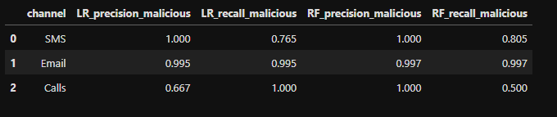
Figure 9. Comparison of model performance per channel.
Table 2. Comparison of model performance per channel.
Channel | LR precision (malicious) | LR recall (malicious) | RF precision (malicious) | RF recall (malicious)
SMS | 1.000 | 0.765 | 1.000 | 0.750
Email | 0.995 | 0.995 | 0.997 | 0.997
Calls | 0.667 | 1.000 | 1.000 | 0.500

Observations:
- Email is the easiest channel for the models: both LR and RF achieve almost perfect precision and recall on phishing emails. The large dataset size and rich text features help greatly.
- SMS shows excellent precision (almost no false positives) but a lower recall around 0.75, meaning some spam messages are still missed, likely short or ambiguous ones.
- Calls are hardest to model due to the tiny dataset:
  - LR prefers to label most malicious calls correctly, reaching high recall but sacrificing precision.
  - RF behaves the opposite: very high precision but lower recall, catching fewer scam calls.
4.3 High-Risk Message Examples (IoCs)
Using predicted probabilities from the Logistic Regression models, the notebook extracts top “high-risk” messages per channel. Typical indicators include:
- SMS spam indicators
  - Phrases like “free entry,” “win cash,” “claim now,” “urgent response”.
  - Presence of phone numbers and shortened URLs.
  - Calls to action in capital letters (e.g., “TEXT NOW TO WIN”).
- Email phishing indicators
  - Subjects combining urgency and account control: “Verify your account,” “Security alert,” “Payment problem,” etc.
  - Messages asking to click a link to avoid account suspension or to update credentials.
  - URLs that visually imitate banks or payment providers but use different domains. Kaggle+1
- Call transcript indicators
  - Statements like “This is your bank security department,” “your account will be locked,” “press 1 to speak to an agent,” “urgent tax issue”.
  - Strong pressure and time-critical language similar to phishing emails but adapted to speech.
These examples can be added to an incident report as Indicators of Compromise (IoCs) to help analysts and users recognize similar attacks.
5. Discussion
From an IT incident investigation perspective, this project provides several important insights into how social engineering attacks manifest across different communication channels and how machine learning can support investigative workflows rather than replace human analysts.
5.1 Most “Dangerous” Channel in the Datasets
Based on the proportion of malicious samples, the phone call channel appears to be the most concentrated in attacks, with approximately 60% of calls labeled as scams, followed by phishing emails at around 56%, and SMS messages at approximately 13% malicious share.
However, this observation reflects dataset design rather than real-world traffic distribution. In operational environments, benign emails and calls typically dominate daily communication, while malicious messages are relatively rare. Therefore, the results should not be interpreted as an absolute measure of real-world risk, but rather as an analytical comparison of detection difficulty across channels.
Despite having the lowest malicious share, SMS spam remains highly dangerous, as it often targets financial data, uses shortened URLs, and exploits the perceived trust of direct mobile communication.
5.2 Best Model for Social Engineering Detection
Across all channels, Logistic Regression with TF–IDF features demonstrates an excellent balance between detection performance and interpretability, making it especially suitable for incident investigation tasks.
For email and SMS, Logistic Regression achieves near-perfect precision and recall, performing on par with or better than Random Forest. This result is expected in text classification problems with high-dimensional, sparse TF–IDF features, where linear models often generalize better and remain more stable.
From an investigative standpoint, Logistic Regression offers an additional advantage:
its learned feature weights allow analysts to understand which words and phrases contribute most to a malicious classification, supporting explainability and evidence-based decision making.
For phone calls, the results highlight a trade-off:
- Logistic Regression prioritizes recall, catching most scam calls but producing more false positives.
- Random Forest prioritizes precision, flagging fewer calls but with higher confidence.
Such trade-offs are common in incident response, where recall is often prioritized to avoid missing active threats, even at the cost of additional analyst review.
5.3 Typical Social Engineering Patterns Across Channels
Despite differences in medium and message length, social engineering attacks across SMS, email, and calls exhibit remarkably consistent linguistic and behavioral patterns, including:
- Urgency: phrases such as “immediately,” “verify now,” “last chance,” “account locked”.
- Authority impersonation: attackers posing as banks, IT support, security teams, or government agencies.
- Forced action: requests to “click the link,” “press 1,” “log in now,” or “call back immediately”.
These recurring patterns confirm findings from prior cybersecurity research and demonstrate how attackers reuse effective psychological techniques across multiple channels. From an investigation perspective, such patterns can be formalized as Indicators of Compromise (IoCs) and reused in detection rules, analyst training, and SOC playbooks.
5.4 Role in the Incident Response Lifecycle
Rather than acting as a fully autonomous security system, the proposed approach is best viewed as a decision-support tool within the incident response lifecycle:
- Detection: automatically flag suspicious SMS, emails, or call transcripts.
- Triage: prioritize high-risk messages for analyst review.
- Analysis: extract linguistic IoCs and attacker tactics.
- Containment support: assist in blocking phone numbers, domains, or campaigns.
- Lessons learned: identify recurring social engineering strategies.
This positioning aligns the project with real-world SOC and incident investigation practices.
5.5 Limitations
Several limitations must be acknowledged:
- The phone call dataset is very small and synthetic, meaning results for calls are not statistically robust and should be interpreted as a proof of concept.
- The models rely on bag-of-words TF–IDF features, which cannot fully capture deeper semantics, context, or novel attacker phrasing.
- The datasets are primarily English-language, while real-world attacks are often multilingual.
- Text-only analysis ignores additional investigative signals such as headers, metadata, user behavior, or audio characteristics.
Despite these constraints, the results demonstrate that even relatively simple models can meaningfully support investigators by rapidly identifying likely social engineering content.
6. Conclusion & Future Work
This project presented a practical and investigation-oriented workflow for analyzing social engineering attacks across SMS, email, and phone calls using machine learning techniques.
Three labeled datasets were integrated into a unified analytical framework, with each channel modeled separately to respect differences in structure and attacker behavior. Using TF–IDF features and classical machine learning models, the system achieved:
- Near-perfect performance on phishing email detection,
- Strong performance on SMS spam classification,
- Reasonable first results on synthetic phone scam data, demonstrating extensibility to voice-based attacks.
Beyond raw performance metrics, the analysis of high-risk messages revealed consistent attacker tactics such as urgency, impersonation, and action-driven language. These findings can directly support incident investigation, evidence collection, and analyst decision-making.
Overall, the project shows that simple, interpretable ML pipelines can transform raw communication logs into actionable investigative insights, serving as a strong baseline for more advanced detection systems.
Future Work
Several directions can further strengthen this approach:
- Larger and realistic call datasets
Incorporating real call transcripts or audio-based features (e.g., MFCCs, speaker behavior) would significantly improve phone scam detection.
- Advanced language models
Transformer-based models such as BERT or domain-specific phishing detectors could improve recall on subtle or low-signal attacks.
- Handling class imbalance
Techniques such as class weighting, resampling, or cost-sensitive learning could better reflect real-world threat distributions.
- Multi-channel correlation
Linking SMS, email, and call signals (e.g., shared phone numbers or domains) could help identify coordinated attack campaigns.
- Explainability and analyst support
Feature importance analysis or SHAP-based explanations could further enhance transparency and trust for investigators.
In conclusion, this work demonstrates how machine learning can effectively augment IT incident investigation, providing timely detection, prioritization, and insight into social engineering threats while keeping the human analyst at the center of the decision-making process.
References
Almeida, T. A., Hidalgo, J. M. G., & Yamakami, A. (2011). SMS Spam Collection Data Set. UCI / Kaggle, SMS Spam Collection. https://www.kaggle.com/code/dejavu23/sms-spam-or-ham-beginner/notebook
Naser Abdullah Alam. CEAS 2008 Phishing Email Dataset. Kaggle. https://www.kaggle.com/datasets/naserabdullahalam/phishing-email-dataset/data

